Week 4: Introduction to Mobile Application Development
Student Name: Precious Jaiyesimi Eniola
Admission number: BIT/2024/39050
Course: Mobile Application Development
School/Faculty: Computing and Informatics, Mount Kenya University_
Program: Information Technology
Academic Year: 4th
Semester: First
Lecturer: Mr Nyoro

Task Completed
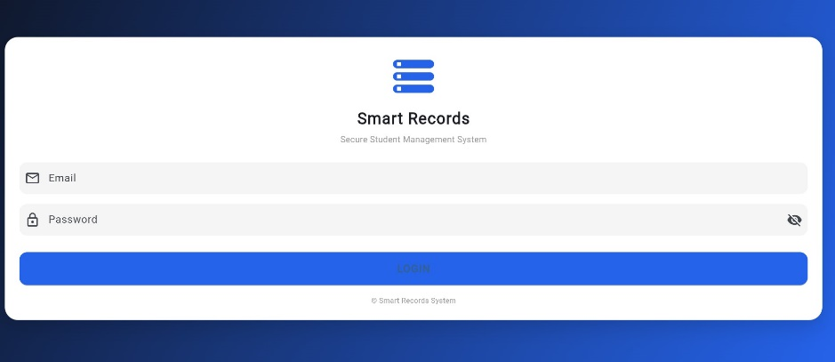
Login Page
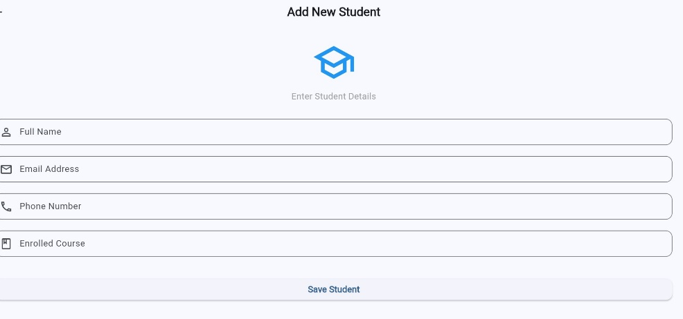
Add student screen

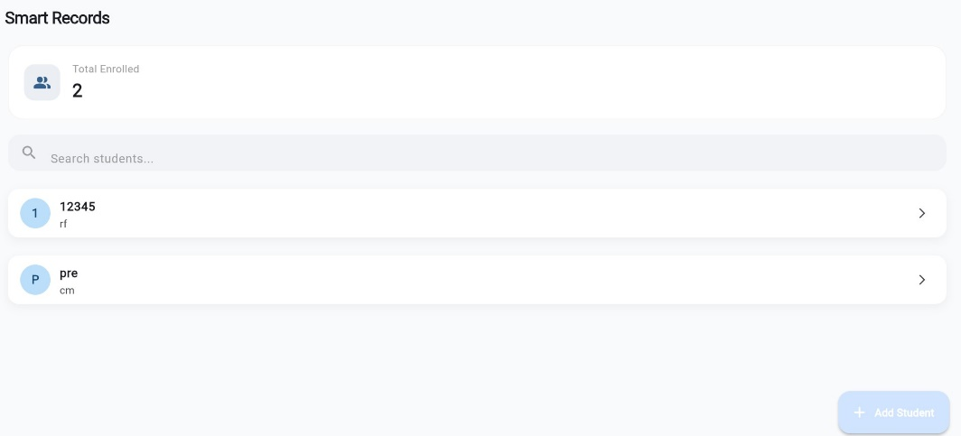
Home screen/ dashboard

Tools/Software Used
- Flutter
- Dart
- Visual Studio Code (VS Code
- Android Studio
- Chrome Browser

Personal Reflection
Week 4 helped me understand Flutter project structure and navigation between screens. I also learned how to fix common errors caused by incorrect imports and formatting issues. I improved my debugging skills and became more confident in organizing files and running the application successfully.

